PF LAB # 4

**Task 4:**

|  |
| --- |
| #include <stdio.h>  int main() {  int marks;  printf("Enter the student's marks: ");  scanf("%d", &marks);  if (marks >= 90)  printf("Grade: A\n");  else if (marks >= 80)  printf("Grade: B\n");  else if (marks >= 70)  printf("Grade: C\n");  else if (marks >= 60)  printf("Grade: D\n");  else  printf("Grade: F\n");    return 0;  } |

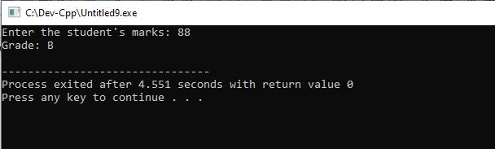

**Task 5:**

|  |
| --- |
| #include <stdio.h>  int main() {  char color[10];  printf("Enter the traffic light color (red, yellow, green): ");  scanf("%s", color);  switch (color[0]) {  case 'r':  printf("Stop!\n");  break;  case 'y':  printf("Ready!\n");  break;  case 'g':  printf("Go!\n");  break;  default:  printf("Invalid color!\n");  }  return 0;  } |

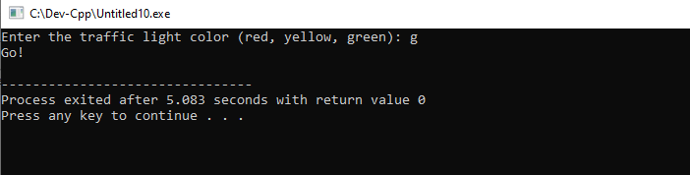

**Task 6:**

|  |
| --- |
| #include <stdio.h>  int main() {  int num1, num2;  char op;  printf("Enter first number: ");  scanf("%d", &num1);  printf("Enter an operator (+, -, *, /): ");  scanf(" %c", &op);  printf("Enter second number: ");  scanf("%d", &num2);  switch(op) {  case '+':  printf("Result: %d\n", num1 + num2);  break;  case '-':  printf("Result: %d\n", num1 - num2);  break;  case '*':  printf("Result: %d\n", num1 * num2);  break;  case '/':  if (num2 != 0)  printf("Result: %d\n", num1 / num2);  else  printf("Error: Division by zero is not allowed.\n");  break;  default:  printf("Error: Invalid operator.\n");  }  return 0;  } |

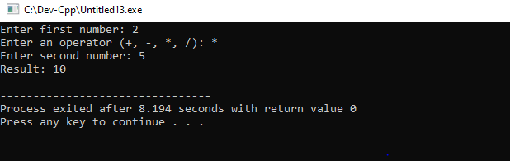

**Task 7:**

|  |
| --- |
| #include <stdio.h>  int main()  {  int year;  printf("Enter a year: ");  scanf("%d", &year);  if ((year % 4 == 0 && year % 100 != 0) || (year % 400 == 0))  printf("%d is a leap year.\n", year);  else  printf("%d is not a leap year.\n", year);  return 0;  } |

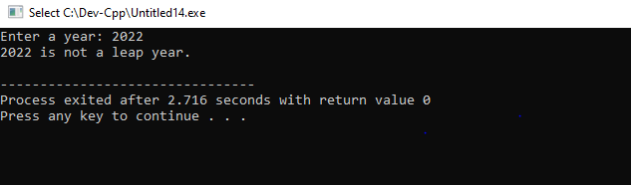

**Task 8:**

|  |
| --- |
| #include <stdio.h>  int main() {  int number;  printf("Enter a number: ");  scanf("%d", &number);  if (number > 0) {  printf("The number is positive.\n");  } else if (number < 0) {  printf("The number is negative.\n");  } else {  printf("The number is zero.\n");  }  return 0;  } |

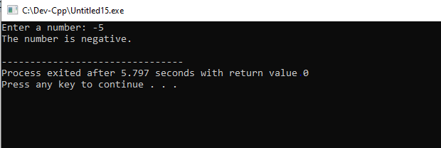

**Task 9:**

|  |
| --- |
| #include <stdio.h>  int main() {  int day;  printf("Enter a number (1-7): ");  scanf("%d", &day);  switch(day) {  case 1:  printf("Sunday\n");  break;  case 2:  printf("Monday\n");  break;  case 3:  printf("Tuesday\n");  break;  case 4:  printf("Wednesday\n");  break;  case 5:  printf("Thursday\n");  break;  case 6:  printf("Friday\n");  break;  case 7:  printf("Saturday\n");  break;  default:  printf("Invalid input! Please enter number between 1 and 7.\n");  }  return 0;  } |

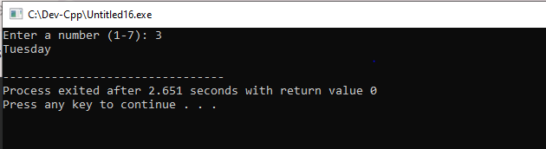

**Task 10:**

|  |
| --- |
| #include <stdio.h>  int main() {  int enteredPassword;  int correctPassword = 7654;  printf("Enter password: ");  scanf("%d", &enteredPassword);  if (enteredPassword == correctPassword)  printf("Access Granted\n");  else  printf("Access Denied");    return 0;  } |

